4-H All Reasonable Efforts and Club Certification Reports

Affirmative action reports are due every year on the first Friday of April. Information about what is required for the report can be found on the DED website at: http://ded.ifas.ufl.edu/resources/affirm.shtml.

4-H Faculty will also need to complete a club certification report. This report can be generated from the 4-H Online Enrollment database. The instructions from pulling the data for the report are below:

- Make sure that all of your club affirmative action data is up to date for the current 4-H year. For step by step instructions on how to update club affirmative action and all reasonable efforts information, refer to section 10 of the 4-H Online Staff Handbook, located on the web at: - http://florida4h.org/staff/4honline/4HOnline_StaffManual.pdf. If club affirmative action info is not entered, then nothing will show up on your certification report.

- Make sure that all club members have been enrolled and are not pending. You can print club rosters and have leaders verify whether or not any of the members are missing.

Once all the club and member info is up to date, you are ready to run your report.

For All Reasonable Efforts: In the Enrollment Tab, click on the REPORTS Icon. Once you are in the reports section, click on the MANAGER REPORTS TAB (the second tab). On the left, click on SHARED reports. Under the STATE File, the Affirmative Action Report is the first report listed. Click on the report, titled “4-H Online Enrollment All Reasonable Reports Club Report (Affirmative Action Info, All Reasonable Efforts)”
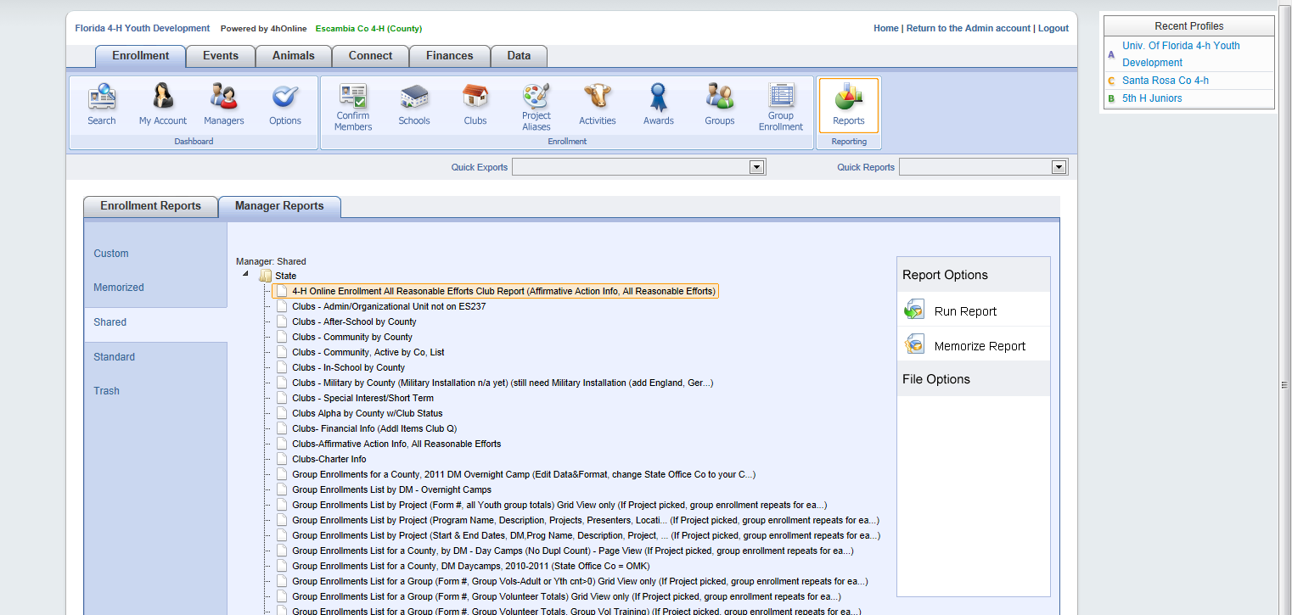

Give a copy of the report to your CED for review/approval, then place a copy in your County Office Affirmative Action File titled “2-3 All Reasonable Effort Certification - 4-H”

