Shared Purpose
Florida Extension Business Professionals Conference, February 8, 2024

Our Session’s Focus
- Understanding team development
- Realizing the power of purpose
- Detecting our team’s purpose

A Comparison

- Groups
- Independent
- Focused on personal objectives
- “Hired-hands”
- Distrustful
- Don’t know how to deal with conflict
- Teams
- Interdependent
- Aligned with team’s objectives
- Take ownership
- Openly communicate
- Recognize conflict is normal

Building Blocks of Effective Teams
- People skills
- Process
- Position
- Purpose

Team Development
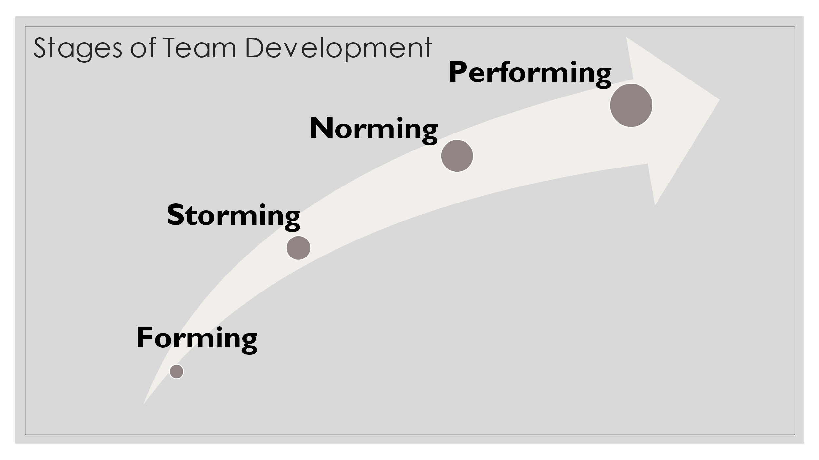

Team Purpose
- Goes beyond tasks and roles
- Your unit’s essential reason for existence

Team Purpose
“No organization will be as effective as it might be until its people understand and support the organization’s strategic purpose.
A muddled sense of purpose leads to confusion and allows people to decide individually what’s important, without any context to guide them.
A clear and galvanizing purpose, on the other hand, focuses everyone’s efforts and moves the organization forward in an unambiguous direction.”
Campbell and Liteman, Retreats That Work

Benefits
- Alignment and direction
- Motivation and engagement
- Unity and collaboration
- Resilience in challenges
- Enhanced decision making
- Employee satisfaction and retention
- Improved communication
- Innovation and creativity
- Customer focus
- Adaptability to change

Process of Development: Questions to Consider
- What do we do?
- For whom do we do it?
- Why does it matter?
- What inspires us about the work we do?

Let’s Try it Out – An Activity
- What do we do?

- For whom do we do it?

- Why does this matter?

- What inspires us about the work we do?

Next Steps
- Discuss the “purpose questions” as a team
  - Create a statement

Reinforcing Structures
- Consider alignments with work
- Check-in annually
- Use during onboarding
- Build on purpose

Some Cautions
- Wordsmithing
- Overcomplicated or too long
- Uninspiring
- Lives only on a website

