How to find Google analytics for specific blog posts
(scroll to bottom for instructions on pulling by author)

Log into Google Analytics NOTE: We recommend using Chrome as your browser for this activity. Agents who have used Firefox tell us the data would not populate in that browser.

Open up a separate tab, in your browser, go to Blogs.IFAS and pull up the specific post you’d like to find analytics for.
In Google Analytics hit Behavior in the left-hand column, then Site Content, All pages
Next, in the upper right-hand side of the page, change the date range to your desired dates. 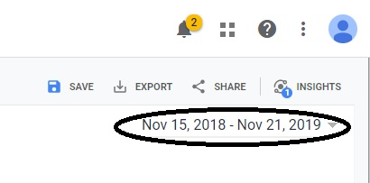
After the date is changed, find your blog post, and copy the similar portion that is depicted below from your post link at the top of your screen. 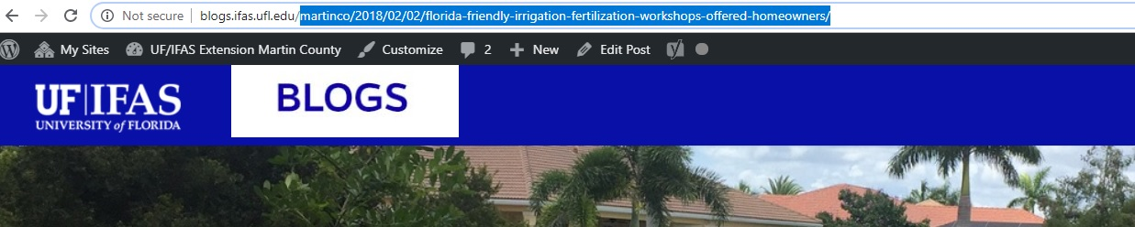
Copy that link address and paste in the4 search field depicted below in the red circle: 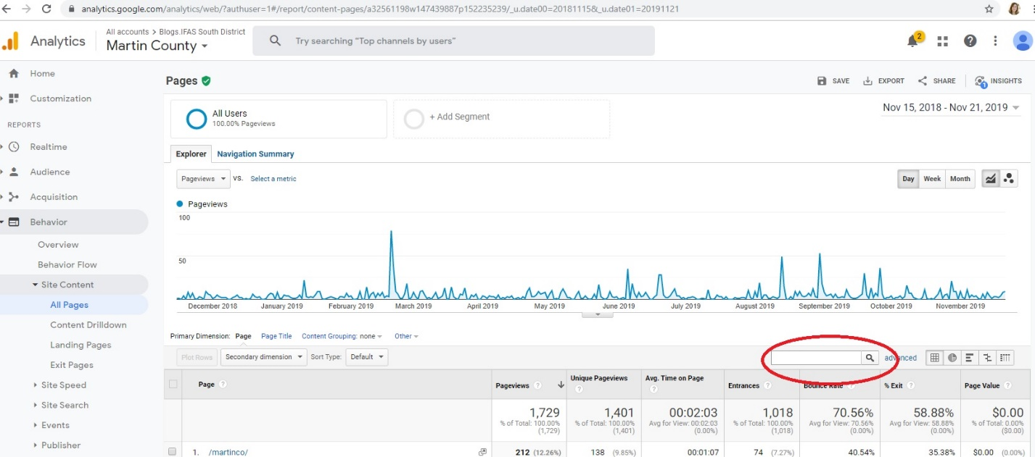

Then hit search and you will find analytics for that post!

Tutorial- Google Analytics Stats by Author
The below shows how to view Blogs.IFAS Google Analytics Stats by Author from dashboard (https://analytics.google.com/).

1. On the left hand side menu bar, go to “BEHAVIOR > Site Content > All Pages”
2. On the right hand view, click the “Content Grouping: none” filter above the table and select “Author (Content Group)”
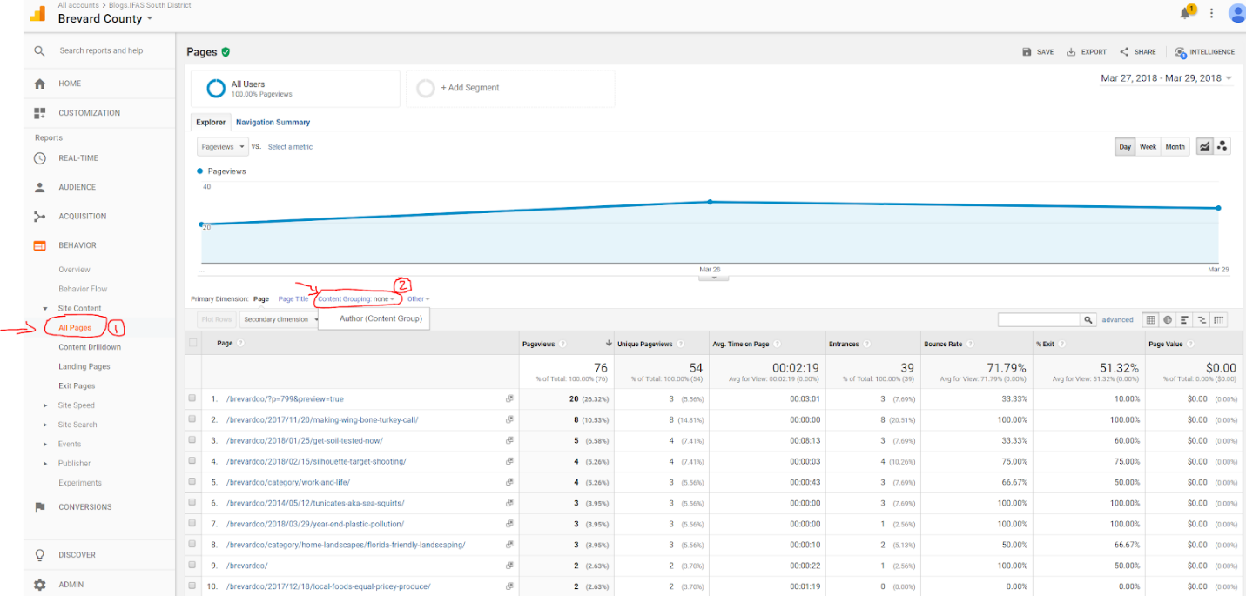
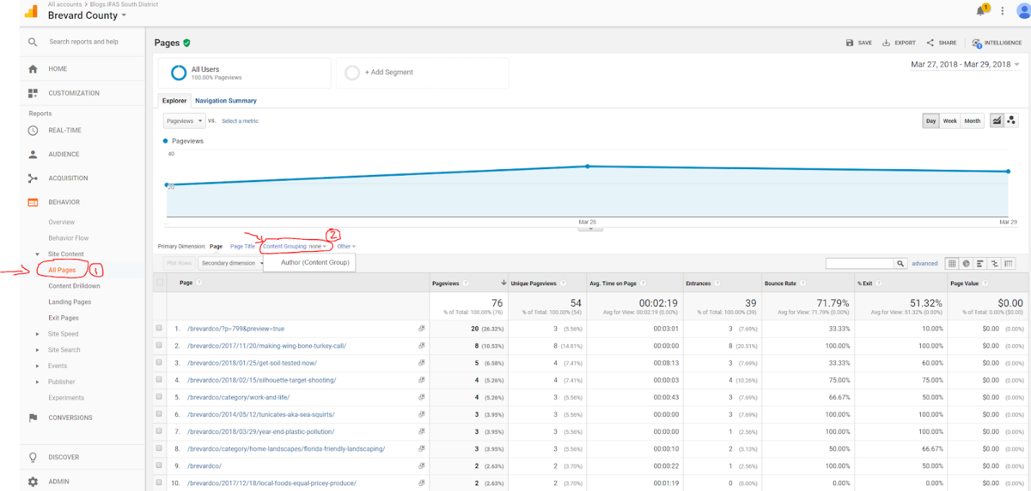
3. You should see “Author (Content Group)” as the first column in the table. “(not set)” and author names are listed there. “(not set)” is for non-blog-post pages with no author related, for example, http://blogs.ifas.ufl.edu/global//brevardco/category/work-and-life/ or http://blogs.ifas.ufl.edu/brevardco/author/gkoerner/

Lastly, select the person’s name and at the top click share, in that new window you’ll see a section where you can check the frequency of which you receive these reports.

