
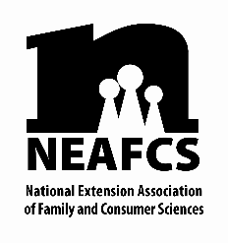
FLORIDA AFFILIATE
FRIEND OF FEAFCS AWARD NOMINATION
(cover sheet)

Nominee Name:
Title:
Address:
Telephone: |  |  |  | Fax:
E-mail:
Title:
Telephone:
E-mail:

- Friend of FEAFCS Award – recognizes individuals or organizations in the business, government, or private sector who demonstrate outstanding support of the Extension Family and Consumer Sciences program through advocacy, collaboration, or financial support. Application is made by submission of a nomination form by an FEAFCS member.

Summarize the contributions for which the nominee has been selected in the space below. (Limit to this one page.)

Note: Nomination may be submitted here by February 17, 2026. If you have any questions, please contact the VP-Awards and Recognition chairperson.

